A Minor Project Report

On

**gps based border alert system for fishermen**

SUBMITTED IN PARTIAL FULFILLMENT FOR THE AWARD OF DEGREE OF

**Bachelor of Technology**

**IN**

**Electronics and Communication Engineering**



**Under the Guidance Of**

**mr.yogesh kumar**

**Submitted By:**

**atul garg (9915102098)**

**rishabh kumar SRIVASTAVA (9915102125)**

**aryan koodi (9915102097)**

**DEPARTMENT OF ELECTRONICS AND COMMUNICATION ENGINEERING**

**JAYPEE INSTITUTE OF INFORMATION TECHNOLOGY, NOIDA (U.P.)**

**CERTIFICATE**

This is to certify that the minor project report entitled, **GPSBASED BORDER ALERT SYSTEM FOR FISHERMEN** submitted by RISHABH SRIVASTAV, ATUL GARG and ARYAN KOODI in partial fulfillment of the requirements for the award of Bachelor of Technology Degree in **Electronics and Communication Engineering** of the Jaypee Institute of Information Technology, Noida is an authentic work carried out by them under my supervision and guidance. The matter embodied in this report is original and has not been submitted for the award of any other degree.

**Signature of Supervisor:**

**Name of the Supervisor:**

**ECE Department,**

**JIIT, Sec-128,**

**Noida-201304**

**Dated:**

**DECLARATION**

We hereby declare that this written submission represents our own ideas in our own words and where others' ideas or words have been included, have adequately cited and referenced the original sources. We also declare that we have adhered to all principles of academic honesty and integrity and have not   misrepresented   or   fabricated   or   falsified   any   idea/data/fact/source   in   our submission.

Place:

Date:

Name:

Enrollment:

Name:

Enrollment:

Name:

Enrollment:

**SYNOPSIS**

This paper describes about the border alerting for fishermen using GPS and engine control unit. In day-to-day life, we hear about the many problems confronted by the Indian fishermen, were captured by the neighboring countries because of crossing the border. The target of this system is utilized to encourage the fishermen to explore inside our sea nation border Using GPS (Global Positioning System)

If the boat nearer to the restricted zone, the alarm will turn on and the sound keep on increasing and also speed of the engine will get reduced. If the fisherman fails to ignore the warning and if they move to the restricted zone then automatically engine gets off and will send the message.

**ACKNOWLEDGEMENT**

We have taken efforts in this project. However, it would not have been possible without the kind support and help of many individuals and organizations. We would like to extend our sincere thanks to all of them.

We are highly indebted to **Mr. Yogesh Kumar** for his guidance and constant supervision as well as for providing necessary information regarding the project and also for his support in completing the project.

We would like to express our gratitude towards staff members of the **JAYPEE INSTITUTE OF INFORMATION TECHNOLOGY, NOIDA** for their kind co-operation and encouragement which help us in the completion of this project.

**TABLE OF CONTENTS**

1. **TITLE PAGE-------------------------------------------------------1**
2. **CERTIFICATE-----------------------------------------------------2**
3. **DECLARATION---------------------------------------------------3**
4. **SYNOPSIS-----------------------------------------------------------4**
5. **ACKNOWLEDGEMENT----------------------------------------5**
6. **TABLE OF CONTENTS-----------------------------------------6**
7. **CHAPTER 1--------------------------------------------------------8**

**1.1 INTRODUCTION-----------------------------------------8**

**1.2 LITERATURE SURVEY--------------------------------9**

1. **CHAPTER 2-------------------------------------------------------10**

**2.1 HARDWARE DESCRIPTION-------------------------10**

**2.2 SOFTWARE DESCRIPTION--------------------------12**

1. **CHAPTER 3-------------------------------------------------------13**

**3.1 METHODOLOGY---------------------------------------13**

**3.2 ABOUT GPS----------------------------------------------14**

**3.3 FLOWCHART/WORKING---------------------------15**

1. **CHAPTER 4------------------------------------------------------17**

**4.1 APP DESIGNING---------------------------------------17**

1. **CONCLUSION AND FUTURE SCOPE------------------19**

**CONCLUSION------ -----------------------------------------19**

**FUTURE SCOPE---------------------------------------------20**

1. **REFERENCES--------------------------------------------------21**
2. **APPENDICES---------------------------------------------------22**

CHAPTER 1

**INTRODUCTION**

**1.1 STATEMENT ABOUT THE PROBLEM:**

The livelihood of fishermen is such that he crosses the country border unknowingly. The sea borders between countries are not easily identifiable which the main reason behind the problem is. In day-to- day life we hear about many Tamil fishermen being caught and put under Srilankan custody and even killed.

Sri Lanka and India seaside nations are isolated by their sea borders. In Tamilnadu about 20,000 vessels make spinning in the Bay of Bengal. The main aim is to give a well equitable user friendly environment for Indian Fisherman to handle hazardous situation with the help of engine control. This paper comes with a consistent solution for this problem and protects the Indian fisherman from dangerous situation and being crossing the maritime boundary and save their life and improve the safety of fisherman.

The system is designed by using GPS[1]. A GPS route device is a device that precisely discovers natural area by getting data from GPS satellites. This device can track the GPS data every single time at whatever point the fisher man's cross the Indian border. It is a significant depression issue and encourages trouble in the both people and also their economic expenditures.

The main application of this system is tracking the vehicle to which the GPS is connected, giving the information about its position whenever required and for the security of each person travelling by the vehicle. This is done with the help of the GPS satellite and the GPS module attached to the vehicle which needs to be tracked.

**1.2 LITERATURE SURVEY:**

D. Jim Isaac and others, the paper titled as “Advanced border alert system using GPS and with intelligent Engine control unit”. In our system using GPS where GPS is used to find the location of the boat. If the boat nearer to the boundary primarily warning the fishermen with the alarm. When it further nears the maritime boundary an interferer is sent to the Engine Control Unit which controls the speed of the engine with the help of the electronic fuel injector and its low cost maritime. By this method, we can alert the fishermen and also monitor them thereby avoiding banned activities such as smuggling.

S. Kiruthika[2] entitled the paper as “A Wireless mode of protected defense mechanism to mariners using GPS technology”. In our system using only GPS to receive the information from the satellite and stored border locations to detect whether the boat has crossed the border or not. If so the mariner is alerted and the message is transmitted to nearby coast office through RF signals at VHF (30-300MHz) range which covers wide area.

Naveen Kumar. M and others titled the paper as Border alert and smart tracking system with alarm, uses GPS to track the location of the boat and to activate an alarm which consists of a Piezo-buzzer, when the border is move toward or crossed. Also, in addition, the GPS information is sent to control office, and also the information is sent to the family at regular time intervals that are in expectation about their family member's safety.

**CHAPTER 2**

* 1. **HARDWAREWARE DESCRIPTION**

**2.1.1 ARDUINO :**

Arduino [3] is an open-source electronics platform based on easy-to-use hardware and software.  Arduino boards are able to read inputs - light on a sensor, a finger on a button, or a Twitter message - and turn it into an output - activating a motor, turning on an LED, publishing something online. You can tell your board what to do by sending a set of instructions to the microcontroller on the board. To do so you use the Arduino programming language (based on Wiring), and the Arduino Software (IDE), based on Processing.

**2.1.2 MOTOR DRIVER:**

A motor driver is a little current amplifier; the function of motor drivers is to take a low-current control signal and then turn it into a higher-current signal that can drive a motor.

We have used motor driver breakout circuit with IC L293D.

**2.1.3 BLUETOOTH MODULE:**

Bluetooth module is used to connect one device to another device with wireless technology. We are using HC-05 because it is cheaper and affordable but we can also use HC-04 and HC-06.

**2.1.4 MOTOR:**

There are 3 types of motor:

* DC motor
* Servo motor
* Stepper motor

DC motor represents the easiest way to add movements to project. Servo motor works same as DC motor but it also has feedback which enables them to precise decisions. Stepper motors are used when it is required very high precision and adjustment.

We have used DC motor as it is cost effective, flexible and simple to be able to move.

**2.1.5 RELAY/TRANSMITTER:**

Relays are switches that open and close circuits electromechanically or electronically. Relays control one electrical circuit by opening and closing contacts in another circuit.  Relays are of two types either electromechanical or solid state relays.

We are using magnetic types of relay.

**2.1.6 GPS MODULE:**

GSM module is used for transmission of message seeking assistance. GSM cannot be used in oceans as towers cannot be placed in oceans. Thus CDMA network or satellites can be used for message transmissions. When vessel crosses border, the stored message along with current latitude and longitude positions is sent to the desired GPS module which is stored already.

We are using GPS module NEO 6-M as it is cheap and user friendly.

**2.1.7 BATTERY:**

There are different types of batteries for different purposes so for Arduino for working we used general 12 volt rechargeable battery.

**2.1.8 OTHER HARDWARE:**

Wires (M-F), Car chassis, Tyres, Breadboard etc.

**2.2 SOFTWARE DESCRIPTION**

**2.2.1 ARDUINO IDE:**

Arduino consists of both a physical programmable circuit board (often referred to as a microcontroller) and a piece of software, or IDE (Integrated Development Environment) that runs on your computer, used to write and upload computer code to the physical board.

**2.2.2 ANDROID APP:**

We have developed an andriod app to connect our robot to mobile with Bluetooth module.

We have used MIT APP INVERTER [] website to build this app.

**CHAPTER 3**

**3.1 METHODOLOGY:**

The GPS device will repetitively give the signal which determines the latitude and longitude and indicates the position of the fishermen and which gets read and displayed in the LCD. The hardware which interfaces with microcontroller and GPS Receiver. GPS provides consistent positioning, navigation, and timing services to users on a continuous basis in every day and night.

Then GPS store the storage of the maritime position. While comparing the previous maritime restricted position and current position and result will be the latitude and longitudinal degree of the boat’s location is determined If the boat nearer to the restricted zone the alarm will turn on and the sound keep on increasing and also speed of the engine will get reduced by using pulse width modulation. In its simplest pulse width modulation output signals are constructed by comparing two signals. The signals are restricted position (carrier signal) and current position (modulation signal) pulse width modulation operating at a low power frequency. While carrier frequency higher than the modulation frequency, the alarm will keep on increasing, if the other case carrier frequency lowers than the modulation frequency, the alarm will keep on decreasing.

Then the fishermen fails to ignore the warning and they move to reaches the restricted zone automatically engine gets off by means of relay and send through the message to the coastal guard. A microcontroller is interfaced serially to GPS receiver. The block diagram of the entire system is given.

**3.2 ABOUT GPS:**

There are three parts to a GPS system: a constellation of between 24 and 32 solar-powered satellites orbiting the earth in orbits at an altitude of approximately 20000 kilometers, a master control station and four control and monitoring stations (on Hawaii[4], Ascension Islands, Diego Garcia and Kawajale) and GPS receivers such as the one in a car.

Each of the satellites is in an orbit that allows a receiver to detect at least four of the operational satellites.

The satellites send out microwave signals to a receiver where the built-in computer uses these signals to work out your precise distance from each of the four satellites and then triangulates your exact position on the planet to the nearest few meters based on these distances.

In fact, signals from just three satellites are needed to carry out this trilateration process; the calculation of your position on earth based on your distance from three satellites.

The signal from the fourth satellite is redundant and is used to confirm the results of the initial calculation. If the position calculated from distances to satellites “A-B-C” do not match the calculation based on “A-B-D” then other combinations are tested until a consistent result is obtained.

**3.3 FLOWCHART/WORKING:**

STORAGE OF RESTRICTED AREA

DATA FROM THE GPS

COMPARE THE POSITION

IF NEARER TO RESTRICTED AREA

NO

B

A

**A B**

ALARM SOUND KEEP ON INCREASING

DIRECTION OF BOAT CHANGES

IF REACHES THE RESTRICTED AREA

N0

**CHAPTER 4**

**4.1 APP DESIGNING:**

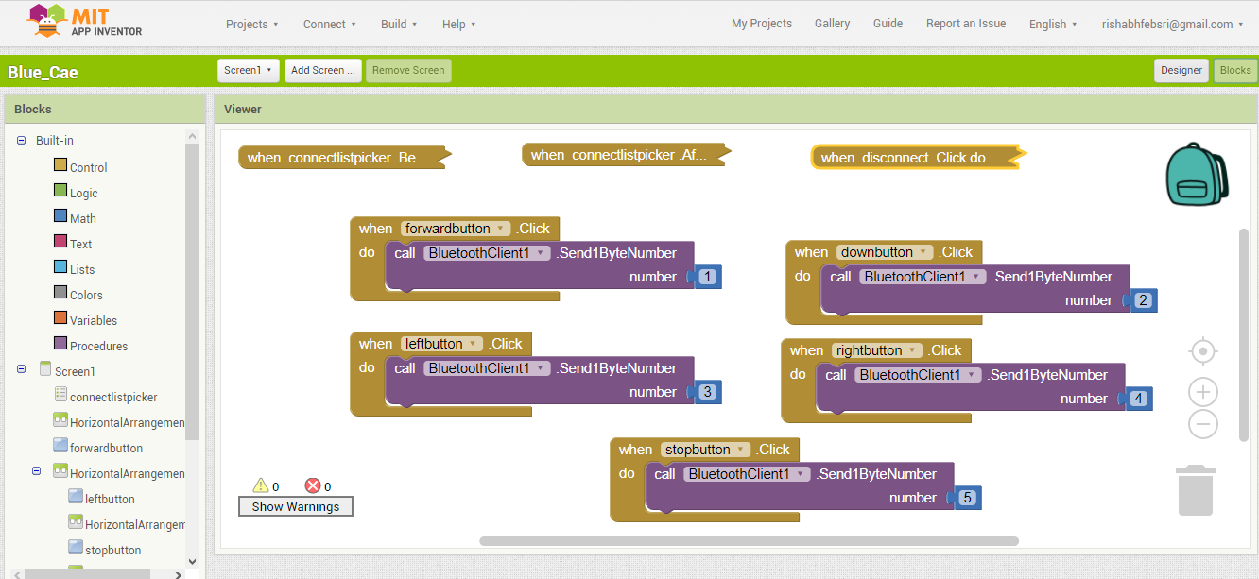

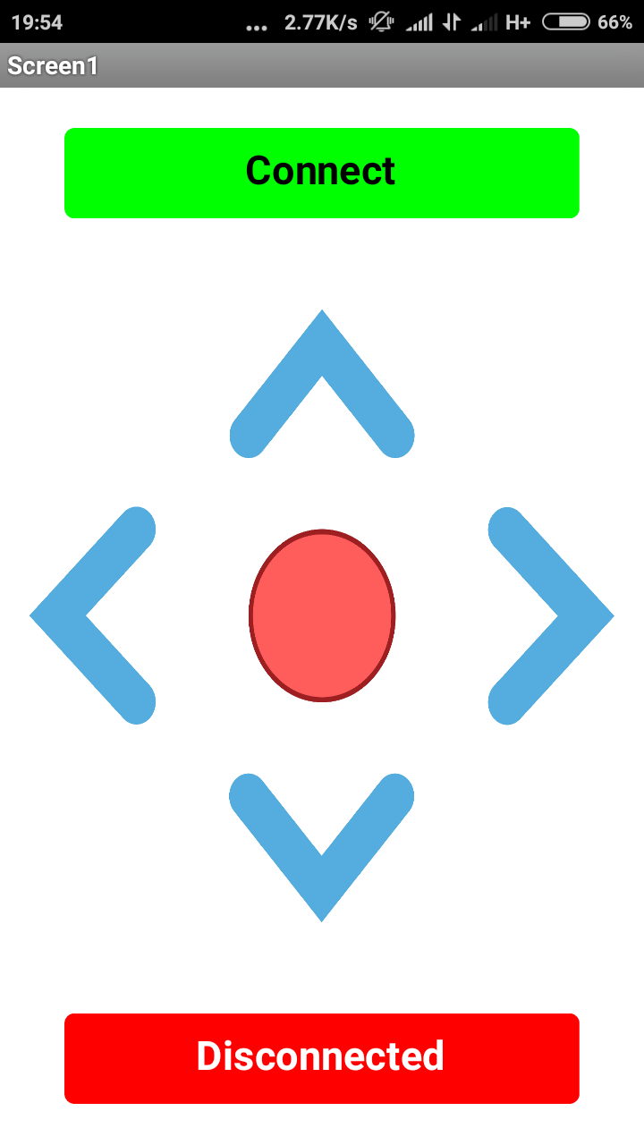

**CONCLUSION AND FUTURE SCOPE**

**CONCLUSION:**

There was a lot of fun in making this project. This project was very useful to us as it provided the information about the daily problems fishermen goes through. GPS based boarder alert system gives a best solution for this problem, whenever the fisherman was about to reach the boundary he can have an alert. So that he can go back from that point onwards.

Our objective is to give wireless support to those fishermen and aside from to go out after them if

They are found missing. This project is a low cost efficient method of wireless tracking. It also gives sufficient information to both ship and coastal guardians of anyone.

Thus the fishermen can easily identify the national sea borders and therefore prevents them from entering their area. Thus saving their lives and providing good relationship with the neighbouring countries. Also, the piracy of ship can be easily brought under control.

**FUTURE SCOPE:**

* We can use the EEPROM to store the previous Navigating Positions up to 256 locations. We can navigate up to N number of location by increasing the memory of EEPROM.
* We can reduce the size of the kit by using GPS the same module of GPS navigator.
* We can increase the accuracy up to 3m by increasing the cost of the GPS receivers.
* By keeping the kits in the entire boats and by knowing the locations of all the boats we can use our kit to assist the traffic.
* In case of any accident on the sea. it can be detected by the system and the accident location of the boat is sent to the rescue team.

**REFERENCES**

**[1]** Jim Isaac , the paper titled as “Advanced border alert system using GPS and with intelligent Engine control unit “International Journal of Electrical and Computing Engineering (IJECE) Vol. 1, Issue. 4, June 2015.

**[2]** S. Kiruthika, A. J. Midhun, N. Krishna, G. Maria Samuel Reuben A.Anguraj5 “Coast guard alert and rescue system for international maritime line crossing of fisherman” at International Journal of Innovative Research in Advanced Engineering (IJIRAE) ISSN:2349-2163 Issue 2, Volume 2 (February 2015).

[3] https://www.arduino.cc/en/Guide/Introduction

[4] http://www.mio.com/technology-what-is-gps.htm

[5] http://ai2.appinventor.mit.edu/?locale=en#5719270360875008

**APPENDICES**

**ALGORITHM:**

//563km/hr

#include <TinyGPS++.h>

#include <SoftwareSerial.h>

const int buzzer = 9; //buzzer to Arduino pin 9

static const int RXPin = 3, TXPin = 2;

static const uint32_t GPSBaud = 9600;

TinyGPSPlus gps;

// The serial connection to the GPS device

SoftwareSerial. ss (RXPin, TXPin);

Void setup () {

 Serial. begin (9600);

 pinMode (4,OUTPUT);

 pinMode (5,OUTPUT);

 pinMode (6,OUTPUT);

 pinMode (7,OUTPUT);

 ss.begin (GPSBaud);

}

void loop() {

 if(Serial. available())

 {

 int z = Serial. read();

 if(z==1)

 {

 digitalWrite(4,HIGH);

 digitalWrite(5,LOW);

 digitalWrite(6,HIGH);

 digitalWrite(7,LOW);

 }

 if(z==2)

 {

 digitalWrite(4,LOW);

 digitalWrite(5,HIGH);

 digitalWrite(6,LOW);

 digitalWrite(7,HIGH);

 }

  if(z==3)

 {

 digitalWrite(4,HIGH);

 digitalWrite(5,HIGH);

 digitalWrite(6,HIGH);

 digitalWrite(7,LOW);

 }

 if(z==4)

 {

 digitalWrite(4,HIGH);

 digitalWrite(5,LOW);

 digitalWrite(6,HIGH);

 digitalWrite(7,HIGH);

 }

 if(z==5)

 {

 digitalWrite(4,HIGH);

 digitalWrite(5,HIGH);

 digitalWrite(6,HIGH);

 digitalWrite(7,HIGH);

 }

 }

 if (ss.available() > 0)

   {

    if (gps.encode(ss.read()))

      {

        if (gps.location.isValid())

  {

   if( (gps.location.lat())>=28.5258 )

    {

      tone(buzzer, 1000);

     digitalWrite(12,HIGH); //danger zone

     digitalWrite(13,LOW);  //safe zone

     }

 if( (gps.location.lat())<28.5257)

     {

    noTone(buzzer);

      digitalWrite(13,HIGH); //safe zone

      digitalWrite(12,LOW);  //danger zone

      }

      }

        }

   }

}